

og RN SHETTY TRUST®
RNS INSTITUTE OF TECHNOLOGY
Autonomous Institution Affiliated to Visvesvaraya Technological University, Belagavi
Approved by AICTE, New Delhi, Accredited by NAAC with 'A+' Grade Channasandra,
Dr. Vishnuvardhan Road, Bengaluru - 560 098
Ph: (080) 28611880, 28611881 URL: www.rnsit.ac.in

Department of Computer Science & Engineering




MAJOR PROJECT-DIARY

Subject Code – BCS685

For Sixth Semester B.E. 2023 Batch [VTU/CBCS, 2022 Scheme]
Batch No. | USN | Student Name
3 | 1RN23CS005 | Abhijeeth K.V
3 | 1RN23CS018 | Akarsh Raj M Hulihalli
3 | 1RN23CS068 | Deepthi D.R
3 | 1RN23CS092 | Jaishnav Kalmangi

2025 - 2026
VISION AND MISSION OF INSTITUTION

Vision
Building RNSIT into a World Class Institution

Mission

To impart high quality education in Engineering, Technology and Management with a Difference, Enabling Students to Excel in their Career by
- Attracting quality Students and preparing them with a strong foundation in fundamentals so as to achieve distinctions in various walks of life leading to outstanding contributions
- Imparting value based, need based, choice based and skill based professional education to the aspiring youth and carving them into disciplined, World class Professionals with social responsibility
- Promoting excellence in Teaching, Research and Consultancy that galvanizes academic consciousness among Faculty and Students
- Exposing Students to emerging frontiers of knowledge in various domains and make them suitable for Industry, Entrepreneurship, Higher studies, and Research & Development
- Providing freedom of action and choice for all the Stake holders with better visibility

VISION AND MISSION OF CSE DEPARTMENT

Vision
Preparing Better Computer Professionals for a Real World

Mission

The Department of Computer Science and Engineering will make every effort to promote an intellectual and ethical environment in which the strengths and skills of Computer Professionals will flourish by
- Imparting solid foundations and applied aspects in both Computer Science theory and Programming practices
- Educating and preparing the graduates, highly sought after, productive, and well-respected for their work culture
- Providing training and encouraging R&D and Consultancy Services in frontier areas of Computer Science with Global outlook
- Supporting and inducing lifelong learning
- Fostering the highest ideals of ethics, values and creating awareness of the role of Computing in Global Environment

Department of CSE, RNSIT

Major Project Phase -I -Evaluation

Sl. No. | Criteria for Evaluation | Max. Marks
A | Synopsis Submission  (i) Problem Identification – 5  (ii) Literature Survey– 5  (iii) Objectives and Scope – 5  (iv) Methodology / Implementation –5 | 20
B | Evaluation-1  (i) Review of Literature Survey – 5  (ii) System Design – 5  (iii)Methodology – 5  (iv) Presentation & Initial Progress – 5 | 20
C | Evaluation-2  (i) Prototype/initial implementation– 5  (ii) Dataset/Tools Identification– 5  (iii) Technical Understanding– 5  (iv) Progress & Planning – 5 | 20
D | Research Paper Preparation & Publication  (i)Writing paper based on literature survey or preliminary work – 5  (ii)Presentation in conference/submission to journal/symposium – 5 | 10
E | Weekly Interaction and weekly report Maintenance  - Weekly Interaction – 5 | 05
F | Project Report  (i)Phase-1 report formatting – 25 | 25
 | Total Marks | 100

Major Project Phase -I -Rubrics

 |  | Criteria | Excellent  (100%) | Good  (80%) | Average  (60%) | Poor  (40%) | Marks
A | Synopsis Evaluation Rubric (20 Marks) | Problem Identification | Problem clearly defined with strong motivation | Problem defined but needs refinement | Problem partially defined | Problem Unclear | 5
A | Synopsis Evaluation Rubric (20 Marks) | Literature Survey | Comprehensive review with recent papers | Good review with few references | Limited review | Very few/no references | 5
A | Synopsis Evaluation Rubric (20 Marks) | Objectives & Scope | Clear, measurable objectives | Objectives mostly clear | Objectives vague | Objectives unclear | 5
A | Synopsis Evaluation Rubric (20 Marks) | Methodology | Well-defined approach with tools identified | Methodology mostly defined | Partial methodology | No clear methodology | 5
B | Evaluation-1 Rubric (20 Marks) | Review of Literature Survey | Critical comparison of research papers | Good understanding of papers | Limited analysis | No analysis | 5
B | Evaluation-1 Rubric (20 Marks) | System Design | Clear architecture/UML/ block diagrams | Good design with minor gaps | Basic design | Poor design | 5
B | Evaluation-1 Rubric (20 Marks) | Methodology | Well-defined approach with tools identified | Methodology mostly defined | Partial methodology | No clear methodology | 5
B | Evaluation-1 Rubric (20 Marks) | Presentation & Initial Progress | Clear explanation and answers | Mostly clear | Some confusion | Poor explanation | 5
C | Evaluation-2 Rubric (20 Marks) | Prototype/ initial implementation | Working prototype developed | Partial implementation | Minimal progress | No implementation | 5
C | Evaluation-2 Rubric (20 Marks) | Dataset / Tools Identification | Proper dataset/tools identified | Tools identified | Limited identification | No clear tools | 5
C | Evaluation-2 Rubric (20 Marks) | Technical Understanding | Strong technical clarity | Good understanding | Moderate knowledge | Weak understanding | 5
C | Evaluation-2 Rubric (20 Marks) | Progress & Planning | Clear future roadmap | Reasonable plan | Partial planning | No plan | 5
D | Research Paper Preparation & Publication  (10M) | Writing paper based on literature survey or preliminary work | IEEE format followed perfectly | Minor formatting issues | Basic structure | Poor structure | 5
D | Research Paper Preparation & Publication  (10M) | Presentation in conference/ submission to journal/ symposium | Project work/Survey Paper is published or accepted in a reputed journal or international/national conference with the student(s) as author(s). | Survey Paper is submitted to a reputed journal or international/national conference and is under review. Work aligns well with the project outcomes. | Survey Paper is prepared in standard format and ready for submission, but not yet submitted. Content reflects the project work adequately. | No publication attempt made or manuscript not prepared. | 5
E | Weekly Interaction and weekly report Maintenance(5M) | Weekly Interaction | Attends all weekly interactions regularly, and submits a well-maintained, detailed weekly report on time. | Attends most weekly interactions and submits a properly maintained weekly report with minor gaps. | Attends weekly interactions but shows limited participation; weekly report is submitted but lacks detail or consistency | No participation in weekly interaction and no report submission | 5
F | Project Report (25M) | Phase-1 report formatting | Report is well-structured and complete. Problem statement, objectives, methodology, results, and conclusions are clearly presented. Content is technically sound, well-written, and properly formatted with correct references. | Report is clear and mostly complete with minor gaps. Technical content is correct. Organization and formatting are acceptable, with minor language or referencing issues. | Report is incomplete or poorly organized. Technical content is minimal. Several sections are weak, unclear, or missing. Formatting and references are inadequate. | Report is poorly written or largely incomplete. Technical content is incorrect or missing. Does not follow the prescribed format or guidelines. | 25

MAJOR PROJECT PHASE -1 TOTAL MARKS

Batch No. | USN | Student Name |  | Marks Awarded |  |  |  |  | Total Marks
Batch No. | USN | Student Name | A | B | C | D | E | F | Total Marks
3 | 1RN23CS005 | Abhijeeth K.V
3 | 1RN23CS018 | Akarsh Raj M Hulihalli
3 | 1RN23CS068 | Deepthi D.R
3 | 1RN23CS092 | Jaishnav Kalmangi

 | Mapping | Justification
PO
PSO
SDG

Project Guide | Project Coordinator | HOD, CSE
Name:  Ms. Chethana H.R | Name:  Ms. Chethana H.R | Name:  Dr. Kiran P
Signature: | Signature: | Signature:

Date:

Sl. No. | Criteria for Evaluation | Max. Marks
A | Synopsis Submission  (i) Problem Identification – 5  (ii) Literature Survey– 5  (iii) Objectives and Scope – 5  (iv) Methodology / Implementation –5 | 20

Batch No. | USN | Student Name | Marks Awarded | Total Marks
Batch No. | USN | Student Name | A | Total Marks
3 | 1RN23CS005 | Abhijeeth K.V
3 | 1RN23CS018 | Akarsh Raj M Hulihalli
3 | 1RN23CS068 | Deepthi D.R
3 | 1RN23CS092 | Jaishnav Kalmangi

Suggestions / Comments (if any): __________________________________________________
_____________________________________________________________________________________
_____________________________________________________________________________________

Panelist - 1 | Project Guide | Project Coordinator | HOD, CSE
Name:  Ms. Chethana H.R  Signature: | Name:  Ms. Chethana H.R  Signature: | Name:  Ms. Chethana H.R  Signature: | Name:  Dr. Kiran P  Signature:

Evaluation-1

Date:

Sl. No. | Criteria for Evaluation | Max. Marks
B | Evaluation-1  (i) Review of Literature Survey – 5  (ii) System Design – 5  (iii)Methodology – 5  (iv) Presentation & Initial Progress – 5 | 20

Batch No. | USN | Student Name | Marks Awarded | Total Marks
Batch No. | USN | Student Name | B | Total Marks
3 | 1RN23CS005 | Abhijeeth K.V
3 | 1RN23CS018 | Akarsh Raj M Hulihalli
3 | 1RN23CS068 | Deepthi D.R
3 | 1RN23CS092 | Jaishnav Kalmangi

Suggestions / Comments (if any): __________________________________________________
_____________________________________________________________________________________
_____________________________________________________________________________________

Panelist - 1 | Project Guide | Project Coordinator | HOD, CSE
Name:  Ms. Savitha T  Signature: | Name:  Ms. Chethana H.R  Signature: | Name:  Ms. Chethana H.R  Signature: | Name:  Dr. Kiran P  Signature:

Evaluation-2

Date:

Sl. No. | Criteria for Evaluation | Max. Marks
C | Evaluation-2  (i) Prototype/initial implementation– 5  (ii) Dataset/Tools Identification– 5  (iii) Technical Understanding– 5  (iv) Progress & Planning – 5 | 20
D | Research Paper Preparation & Publication  (i)Writing paper based on literature survey or preliminary work – 5  (ii)Presentation in conference/submission to journal/symposium – 5 | 10
E | Weekly Interaction and weekly report Maintenance  (i) Weekly Interaction – 5 | 05
F | Project Report  (i)Phase-1 report formatting – 25 | 25

Batch No. | USN | Student Name | Marks Awarded |  |  |  | Total Marks
Batch No. | USN | Student Name | C | D | E | F | Total Marks
3 | 1RN23CS005 | Abhijeeth K.V
3 | 1RN23CS018 | Akarsh Raj M Hulihalli
3 | 1RN23CS068 | Deepthi D.R
3 | 1RN23CS092 | Jaishnav Kalmangi

Suggestions / Comments (if any): __________________________________________________
_____________________________________________________________________________________
_____________________________________________________________________________________

Panelist - 1 | Project Guide | Project Coordinator | HOD, CSE
Name:  Mr. Vallabh Kulkarni  Signature: | Name:  Ms. Chethana H.R  Signature: | Name:  Ms. Chethana H.R  Signature: | Name:  Dr. Kiran P  Signature:

Weekly Interaction and weekly report Maintenance

Project Title: Swarm based Agriculture Monitoring System (SAMS)

Project Guide: Ms. Chethana H.R

Sl.  No | Date of Meet | Topic Discussed | Absentee student details | Sign. of the Guide | Sign. of the  coordinator | Sign of the HOD | Remarks
1.

Sl No | Phase -1 Submission | Date | Remarks
1 | Synopsis Submission | 18/03/26
2 | Patent Filling | 30/03/26
3 | Paper First Submission with Plagiarism | 27/04/26
4 | First Draft Report Filing | 27/04/26
5 | Final Report draft with Plagiarism | 30/04/26
6 | Final Hard bound report submission | 06/05/26

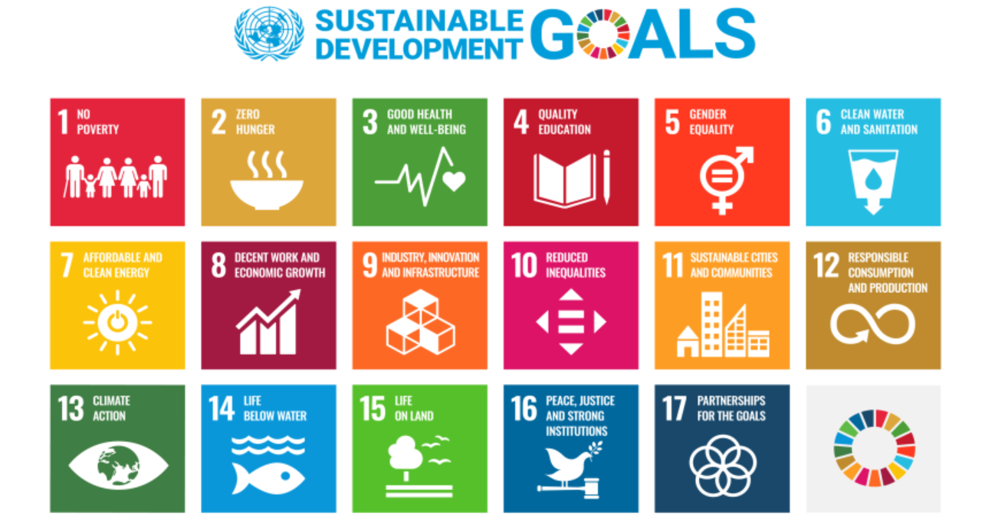

UN SDGs:
- No poverty
- Zero hunger
- Good health and well-being
- Quality education
- Gender equality
- Clean water and sanitation
- Affordable and clean energy
- Decent work and economic growth
- Industry, innovation and infrastructure
- Reduced inequalities
- Sustainable cities and communities
- Responsible consumption and production
- Climate action
- Life below water
- Life on land
- Peace, justice, and strong institutions
- Partnerships for the goals

